THE
MERIDIAN
PROGRAMME
HUMAN INTEGRATION for TOMORROW’S WORLD
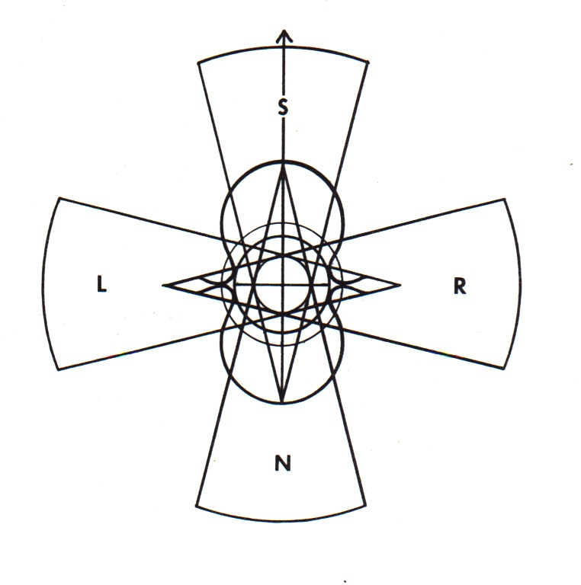
MERIDIAN HOUSE

115 POPLAR HIGH STREET

LONDON E14 0AE
Tel: 020 7-987 3600
Fax: 020 7-515 8627
e-mail: meridianprogram@aol.com
Web-site: www.meridian.org.uk

Hosted by: Unit for Research into Changing Institutions (URCHIN), Charity Reg. No. 284542

10th December 2002

To whom it may concern

Re: Open letter on World Dynamics

As Director of the Meridian Programme, I find myself in somewhat of a unique position to bring together into a single document insights and contributions from professional colleagues in the fields of psychoanalysis, psychohistory and systems analysis which have a critical bearing on our current international situation. The product is of course always open to revision and improvement, but will I hope serve as a foundation for continuing work as we seek to raise awareness of the powerful non-rational and unconscious elements of our collective behaviour.

There would appear to be a window of opportunity for reflection on the process of world dynamics occasioned by the activity of the UN weapons inspectors within Iraq. It is one of those moments in history when action may appear to be the height of arrogance, but when failure to act is the height of social irresponsibility.

The effectiveness of the intervention depends on reaching the largest possible number of responsible people in the shortest possible time. Once you have had a chance to read and consider the document you could play an important and active role in its further distribution together with this covering letter. Some of the practical steps you might be able to take are:

- To cascade the text through e-mail lists
- To place copies on strategic web-sites, on notice boards or in chat-rooms
- To ensure maximum exposure through the media of television, radio, newspapers, magazines and journals
- To circulate through membership of networks and organisations
- To bring it to the attention of friends, associates or professional colleagues
- To distribute it to people in positions of leadership in business, politics and academics
- To translate it into another language to ensure the widest possible international access

To assist you in your task, the letter is available in hard copy, as text in the body of an e-mail, as an attached Word file. It is also accessible via our web-site at www.meridian.org.uk in both HTML and PDF formats.

With best wishes,

David Wasdell

THE
MERIDIAN
PROGRAMME
HUMAN INTEGRATION for TOMORROW’S WORLD
MERIDIAN HOUSE

115 POPLAR HIGH STREET

LONDON E14 0AE
Tel: 020 7-987 3600
Fax: 020 7-515 8627
e-mail: meridianprogram@aol.com
Web-site: www.meridian.org.uk

Hosted by: Unit for Research into Changing Institutions (URCHIN), Charity Reg. No. 284542

10th December 2002

An open letter to:

Kofi Annan, General Secretary of the United Nations,
Tony Blair, Prime Minister of the UK.
George Bush, President of the USA.
All others in responsible positions of leadership of the world community.

In my role as Director of the Meridian Programme (formerly the “Manhattan Project of the Behavioural Sciences”) I have recently been involved in a series of international conferences in France, Hungary, UK and the USA which have brought together some of the world’s leading psycho-social analysts. There is a sufficient convergence of understanding of the dynamics of the current international situation to warrant bringing the following points to your attention as a matter of some urgency:

- That factors which are non-rational and largely unconscious play a major part in the dynamics of international relationships and decision-making. It is critical that this level of understanding of systems behaviour is taken into consideration by all concerned irrespective of their political, religious, national or ethnic affiliation.

- That in the post September 11 context, large sectors of the international community are acting out classical symptoms of post-traumatic shock syndrome. The intensity of emotion involved reinforces fixation in the moment of shock and the tendency to re-stage the event in repeated cycles of displacement.

- That the intensity of personal and collective grief occasioned by that event has been profoundly underestimated. Unresolved mourning is commonly transmuted into inappropriate aggressive behaviour, particularly in cultures that have difficulty in dealing with issues of mortality and death.

- That primitive and simplistic dynamics of splitting are dominant. Sectors of the world community are seen either as good or as evil. Negative elements of the “good” sectors are suppressed and denied, positive elements of the “evil” sectors are also suppressed and denied.
- That sector leaders involved in the resultant polarities take up mirror positions to each other. The “home” sector is seen as good, in the right, offended against, holding the moral high ground, an innocent victim, totally justified in defending itself or escalating the conflict in a mode of righteous retaliation. The position is identical whichever side of the polarity is considered.

- That de-humanisation of the “enemy” results in massive imbalance in the value afforded to human life between the in-group and the out-group. This supports acts of aggression that over-emphasise casualties to the in-group while discounting casualties suffered by the out-group.

- That empathic cultural awareness is severely diminished, rendering it extremely difficult to appreciate how a situation is perceived from another point of view. For example, in the search for some reason behind the “acts of terrorism”, many Americans find it impossible to comprehend the enormity of the sense of desecration and violation of the sacred space of the Holy Land of Islam which took place inadvertently during the Gulf War.

- That actions and interventions transfer the emotional and unconscious state of the actor into the emotional and unconscious life of the receptor. Terror, distress and outrage may lead to an act of aggression which leaves the victim in a state of even greater terror, distress and outrage. Reaction in kind sets up an escalating cycle of destruction, reinforcing the underlying dynamics and obliterating any possibility of understanding and resolution.

- That social trauma generates behaviour in the victim which reflects and matches the culture of the aggressor. This internalisation of dysfunctional dynamics underlies recent shifts in American life towards conformity with the culture of fundamentalism, social oppression and the suppression of difference and dissent.

- That current events trigger the release of emotional response associated with past experience whether individual or collective. The re-stimulated unconscious anxiety (which may be from a failed abortion attempt, early loss of twin or other close family member, birth trauma, circumcision, stressful separation, child abuse, etc.) then distorts present social attitudes and political decision-making.

- That leadership emerges in large groups and social systems when there is a match between the unconscious dynamics and defences of the leader and the unconscious needs and wishes of the led. This relationship between pathology and politics exposes the system to significant risk in times of transition or crisis. Thus over-identification with the bereaved after 9.11 stemming from intense family bereavement trauma illuminates the intensity of the bond between President Bush and Prime Minister Blair and the collusional congruence of their political response.

- That the identification or provocation of an external enemy unifies the internal dynamics of any group, nation or state. Internal differences, ambivalence and negativities are obliterated and projected outwards onto the enemy-as-scapegoat. The process may strongly reinforce the power and popularity of religious or political leadership, but it undermines the capacity for rational and reality-based decision-making.

- That the global context of the human species within its holding environment is raising increasing social anxiety about future viability. The result is an increasing state of collective paranoia coupled with despair and impotence in the face of the enormity of scale and difficulties encountered in mobilising effective international action. The heightened sense of threat seduces and deflects energy into internecine conflict, diverting attention from long-term problem-solving, diminishing the capacity for global collaboration and severely enhancing the environmental degrade and resource attenuation which underlie the presenting symptoms.

- That another response to the global situation is the social retreat into passivity, dissociation, collective trance and anxiolytic behaviour. Energy is invested in attempts to sedate the presenting symptoms of anxiety rather than focussed on the underlying problems which are causing it.

- That heightened social anxiety leads to the reinforcement of fundamentalist ideologies, whether philosophical, political, economic or religious. These constructs defend individuals and systems from anxiety while detaching them from reality. Extreme pressure for conformity and collusion are experienced within the groups concerned, while intense conflict is engendered at their boundaries.

- That the degree and intensity of dynamic disturbance in the world system reflect the severity of the emergent anxiety in the system as a whole. (See appended “Core Analysis of Global Dynamics”.) Responses and interventions that serve to reinforce the long-term causes of the anxiety are dysfunctional in the extreme, however appropriate they may seem from a short-term and limited perspective.

- That in a world that is interrelated in real time by the communication media, reinforcing feed-back loops can severely accelerate and enhance the dysfunctional system dynamics. It is vital that all involved in the media should become increasingly aware of the unconscious factors at work and of their own role and responsibility within that process.

- That the current global context requires the ability to see the world system as a whole and to operate with the viewpoint of an extended time span. Even though individual business or political leaders may have risen to power at the head of distinct sub-systems, they share a collective responsibility to optimise the long-term viability of the world community as a whole. Maximisation of sub-system goals at the expense of the whole or the achievement of short term gain at the expense of long-term degrade are no longer sustainable strategies.

- That it is now imperative to develop effective means by which all concerned with leadership of our world community can be enabled to take cognisance of the powerful non-rational and unconscious dynamics which operate in social systems.

While this document draws together insights from many sources reflecting the convergence of analysis within the professional community, I myself carry full responsibility for the form and content of the initiative.

David Wasdell
Director, Meridian Programme

Core Analysis of Global Dynamics

Over the many millennia of recent evolution, increasing and universal traumatisation in the process of birth has led to repressed physical and psychological pain and its associated defences. This profound and shared state of normal pathology forms the ground of our common or collective unconscious.

Normal fixation at the onset of perinatal trauma, together with consequent regression to an idealised pre-natal environment, drive a socially resonant dynamic syndrome. It is characterised by an unconscious identification with the foetal state, seeking to reconstitute an idealised foetal context, albeit fraught with anticipatory terror of the imminent onset of the trauma of birth.

The collective acting-out of the material in repetitious social psychodrama forms the basis of every level of our civilisation. It presents in the dynamics of war and religion, of politics, economics and environmental relations. It is constructed and reified in art and architecture, philosophy and ideology.

Under certain conditions normal defences used to contain the experience in unconscious repression are weakened, precipitating an acting-out of birth trauma in collective behaviour. Current global conditions constitute precisely such a context on a massive scale. Living space is constricted, resources are seen as inadequate to sustain current or future patterns of growth, the pace of change is accelerating, increased pressure is universally experienced and issues of environmental pollution are significant. Collective identification of the species as mega-humanoid foetus within its global uterine space, leads to the perception of reaching critical mass within its holding environment. Under these conditions the collective foetal assumption is that the titanic struggle of birth is imminent. Realistic anxiety about the actual condition of the species is massively inflated by re-stimulated anxiety released from the collective unconscious, the threatened acting-out of which on a global scale probably constitutes the most severe crisis ever encountered by our human species.

